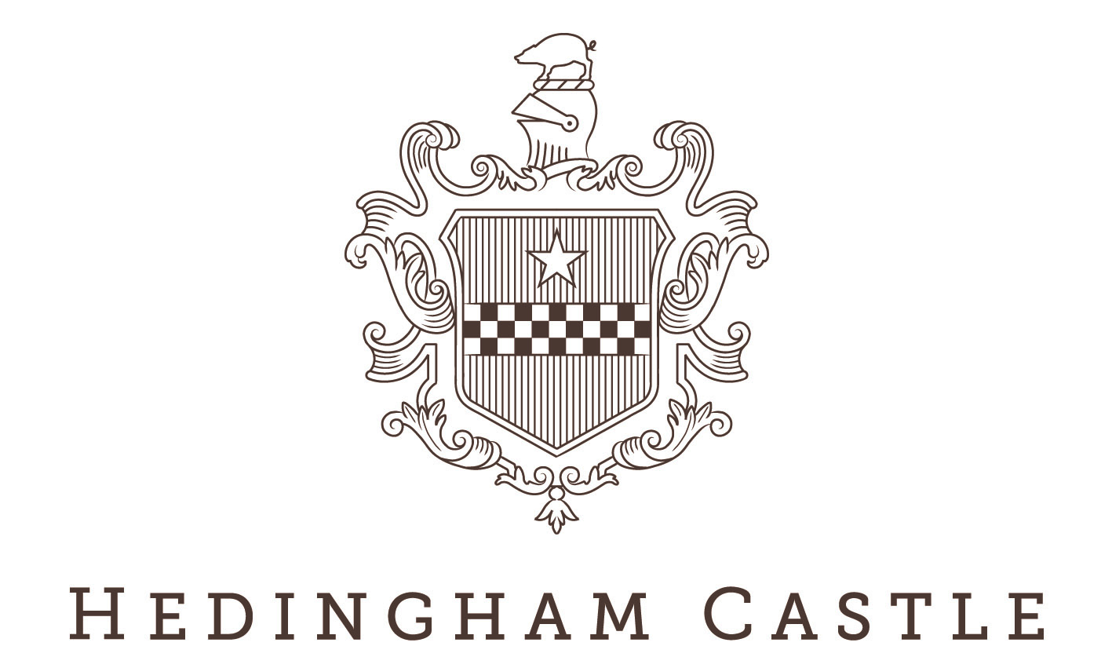

Classic & Vintage Car Show - Sunday 18th August 2024

Please return this form either by email to jenny@hedinghamcastle.co.uk or by post to Hedingham Castle, Castle Hedingham, CO9 3DJ marked as “Classic & Vintage”.
FORMS MUST BE RETURNED BY 12TH JULY 2024

NAME

ADDRESS

POST CODE

EMAIL

VEHICLE TYPE (please circle/delete/highlight): CAR / MOTORBIKE

VEHICLE MAKE MODEL

REGISTRATION COLOUR

YEAR FIRST REGISTERED

CLUB NAME (OPTIONAL)

PLEASE CIRCLE/HIGHLIGHT THE FOLLOWING CATEGORY FOR YOUR VEHICLE:

VINTAGE & PRE 1940S CLASSIC MODERN CLASSIC MODERN INTEREST*
(1940 – 1970) (1971-1986) (1987 – now)

*Modern interest cars must be preapproved for entry by Hedingham Castle.
Please note that we will confirm bookings by email, tickets will not be issued.

Terms and Conditions
- All cars attend the event entirely at the owner’s risk.
- Hedingham Castle do not accept any liability for any damage to owners’ vehicles whilst on site.
- Club members will be allocated space within their club area.
- All cars will be parked at the discretion of Hedingham Castle.
- The static display shall commence at 11am and finish at 4pm.
- All cars must be in position by 10:45am and remain until 4pm.
- Complimentary pass included for driver and 1 guest. Further guests welcome but must purchase tickets.
- Exhibitors are asked to take extra precautions on uneven ground and stairs of the Hedingham Castle estate. Hedingham Castle cannot accept liability for any accidents that may occur on their grounds.

For Office Use

Date returned Confirmed

